***similar triangles***

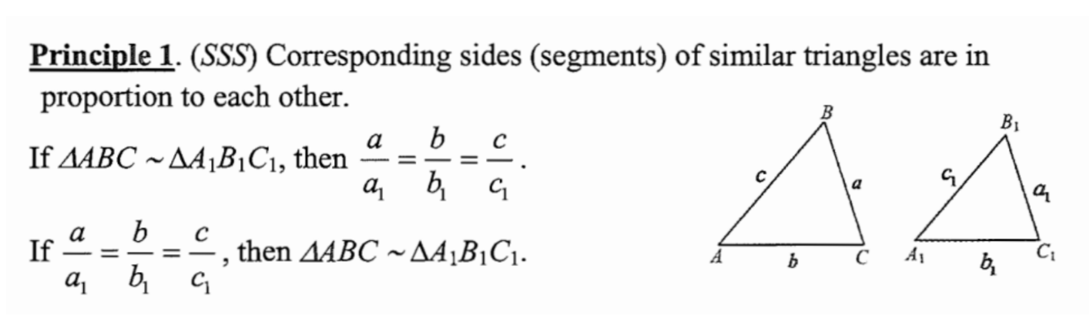

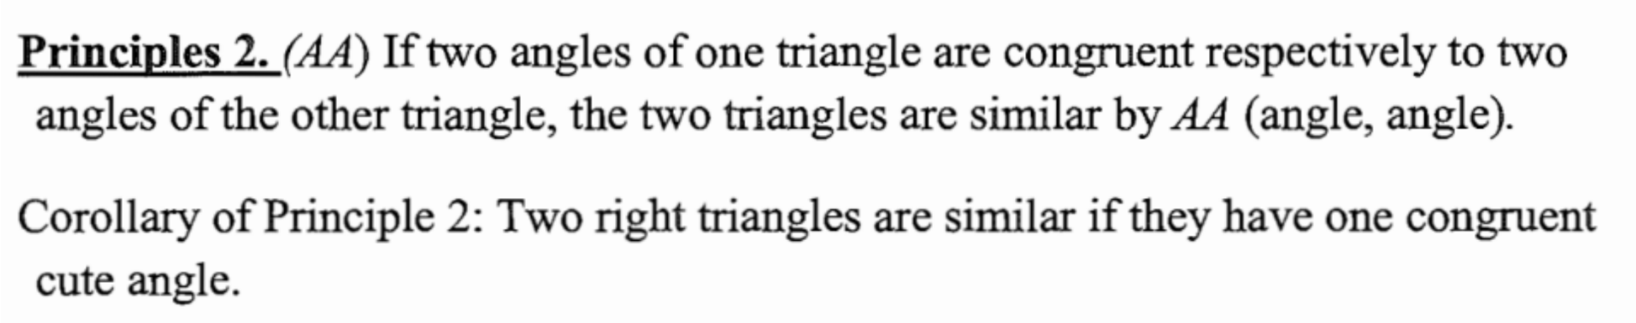

a

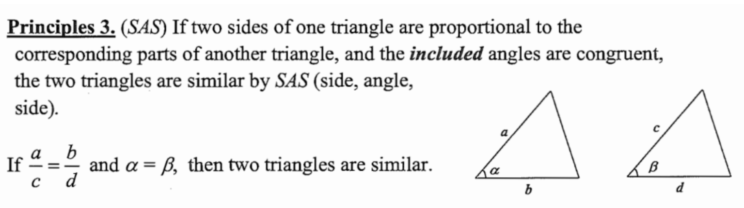

Theorems:

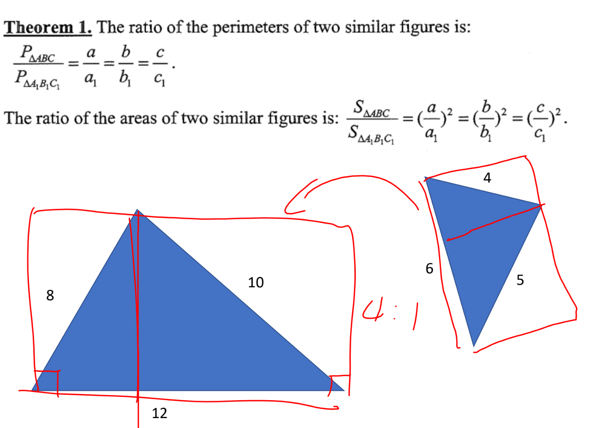

Highly important theorem (proved near the end of this document)

It is important to memorise, more important to prove.

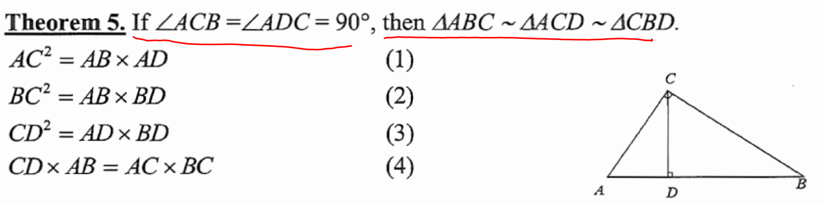

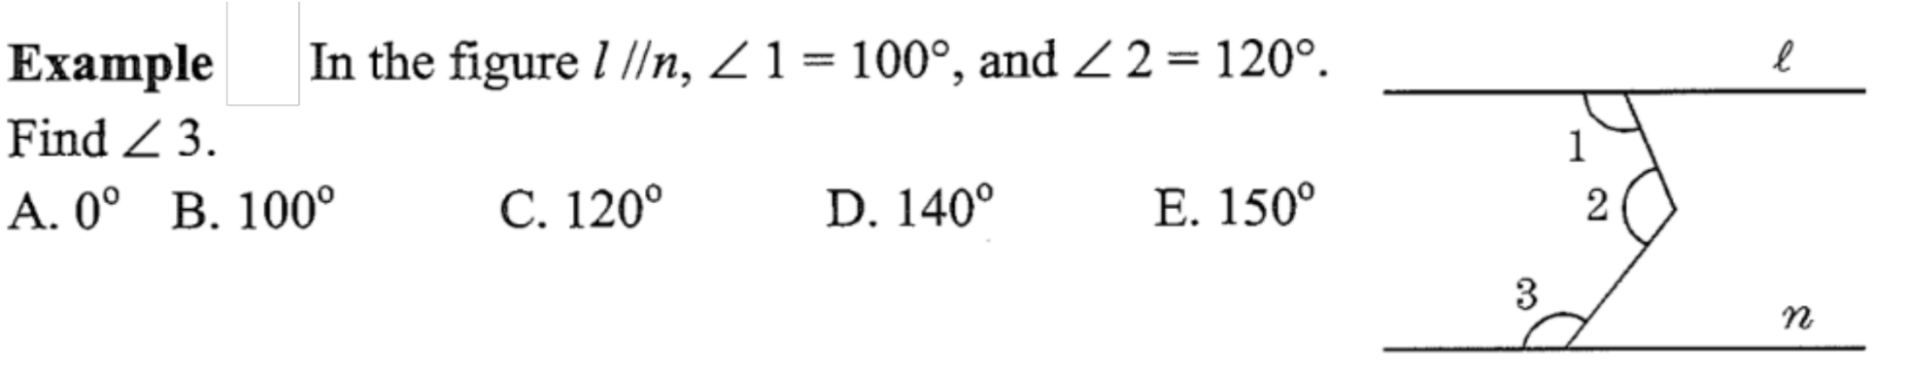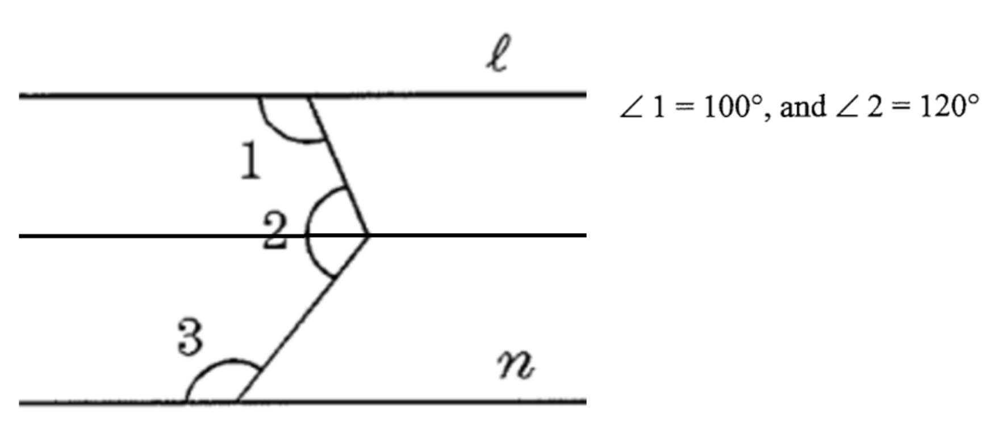

Similar triangles are always triggered by parallel lines, except in the case of theorem 5 above. As the above example shows, we can create parallel lines.

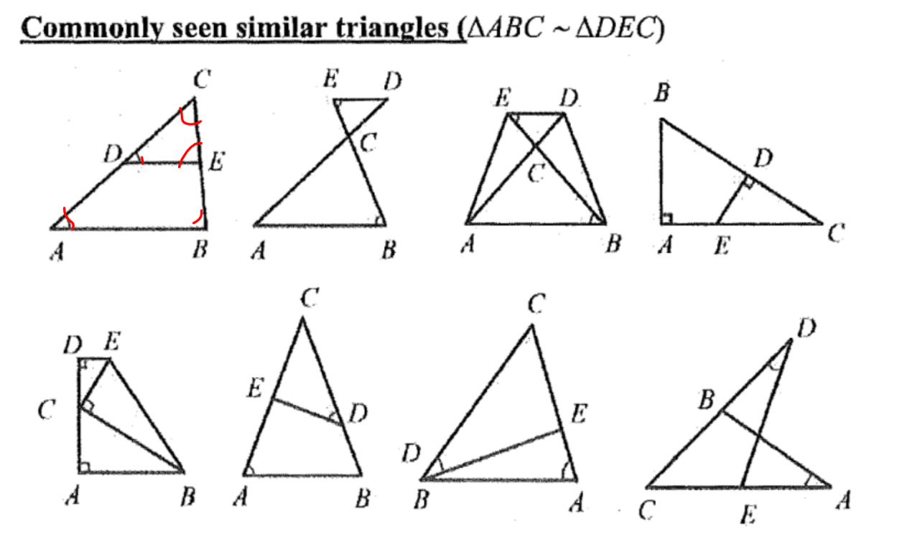

More examples

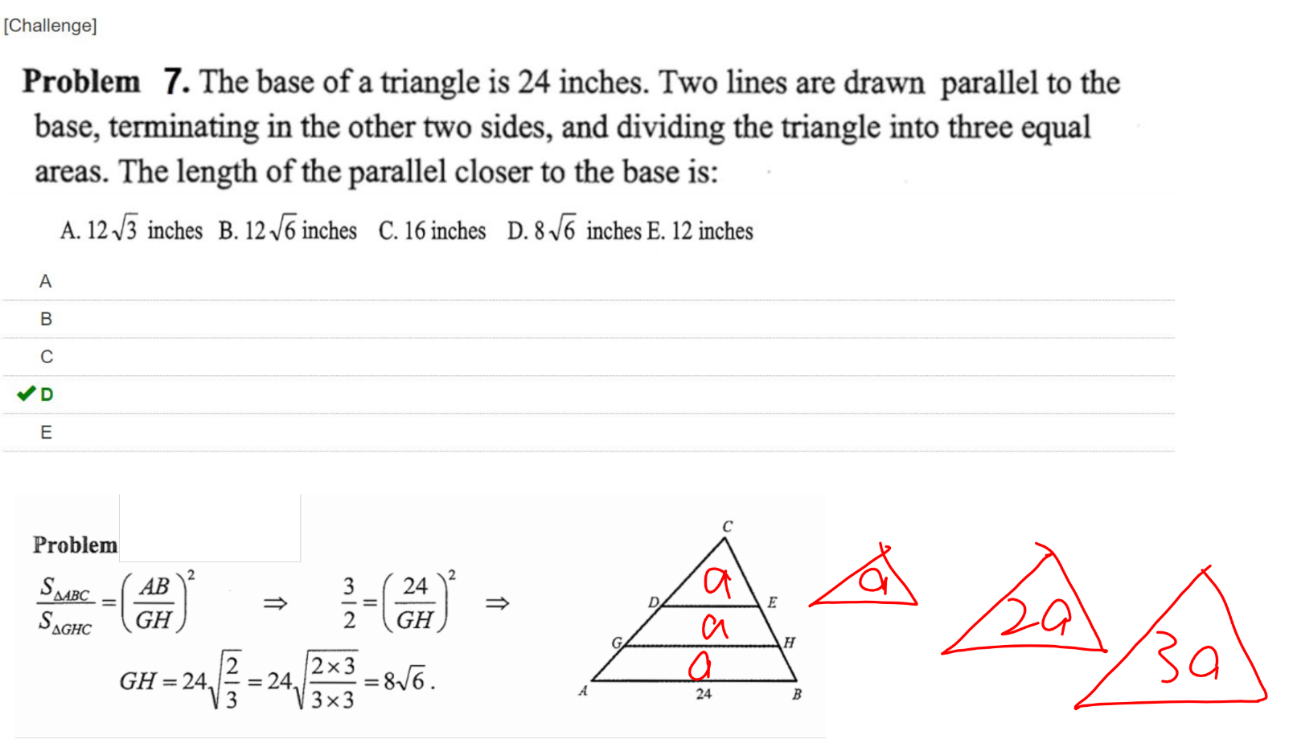

In the first equation, the ratio of ab:gh is squared because of (theorem 1)

Very hard question:

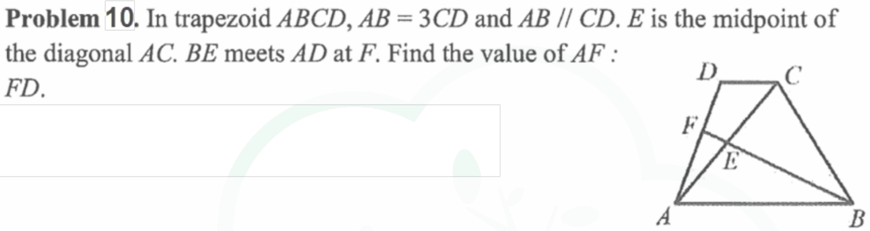



As illustrated above, we added point G to create similar triangles, and labelled DC and AE with units. Note that GCE and ABE are actually congruent as their corresponding sides AE and EC are the same. Now since GC=AB we know that GD is 2. Also note the similar triangles AFB and GDF. From that we know that AB:GD = AF:FD = 3:2, so the ratio of AF to FD is 3:2.

Similar triangles conclusion:

The motivation of similar triangles is usually parallel lines, so always try to use it in the case of parallel lines

Highly IMPORTANT!! :



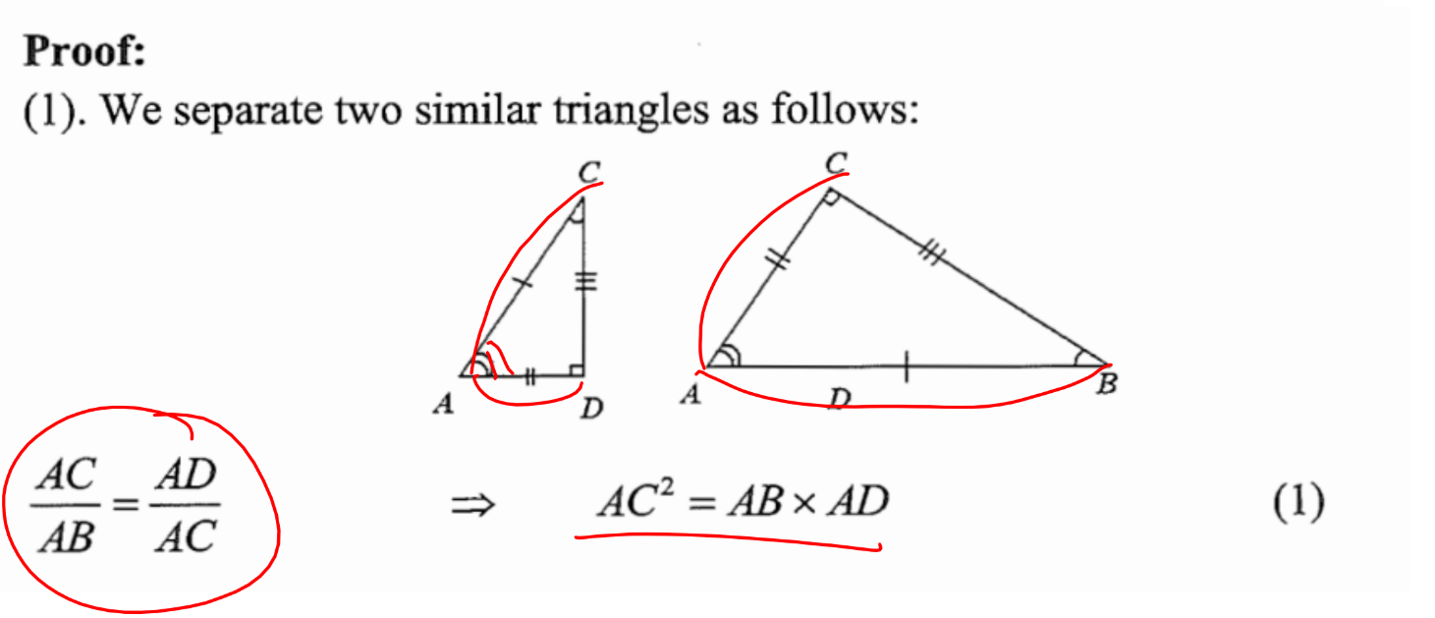

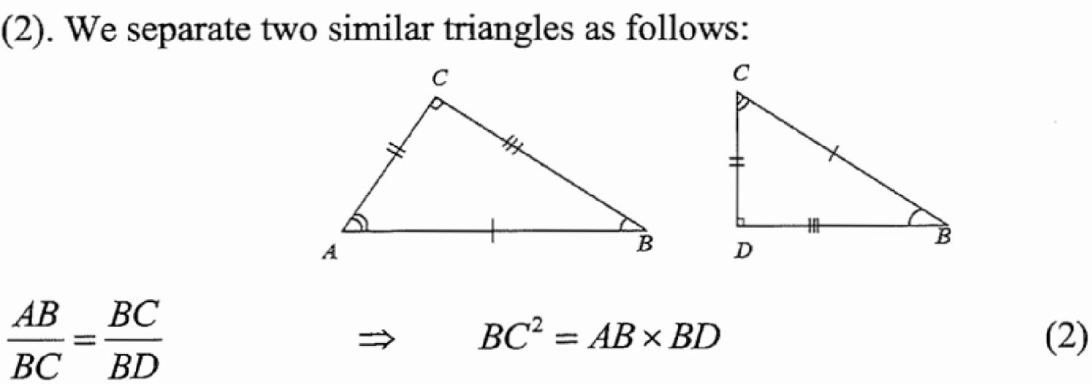

(3)

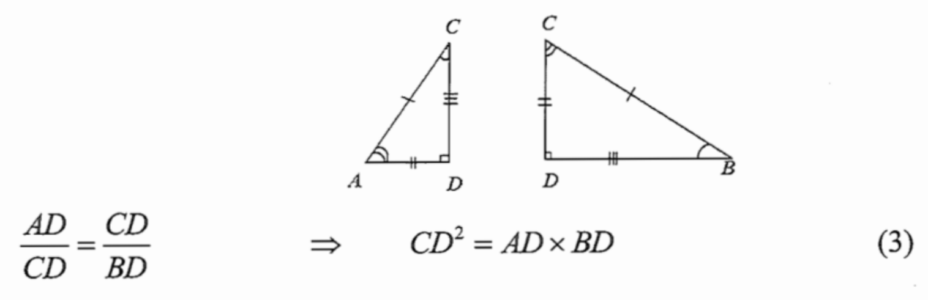

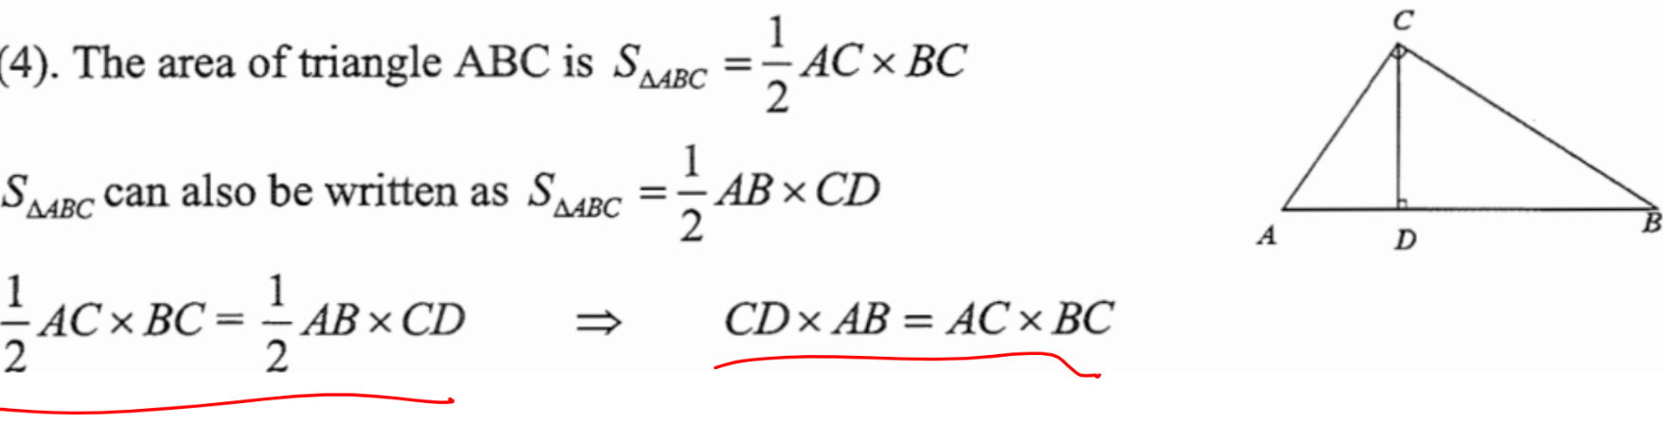

Example regarding theorem 5

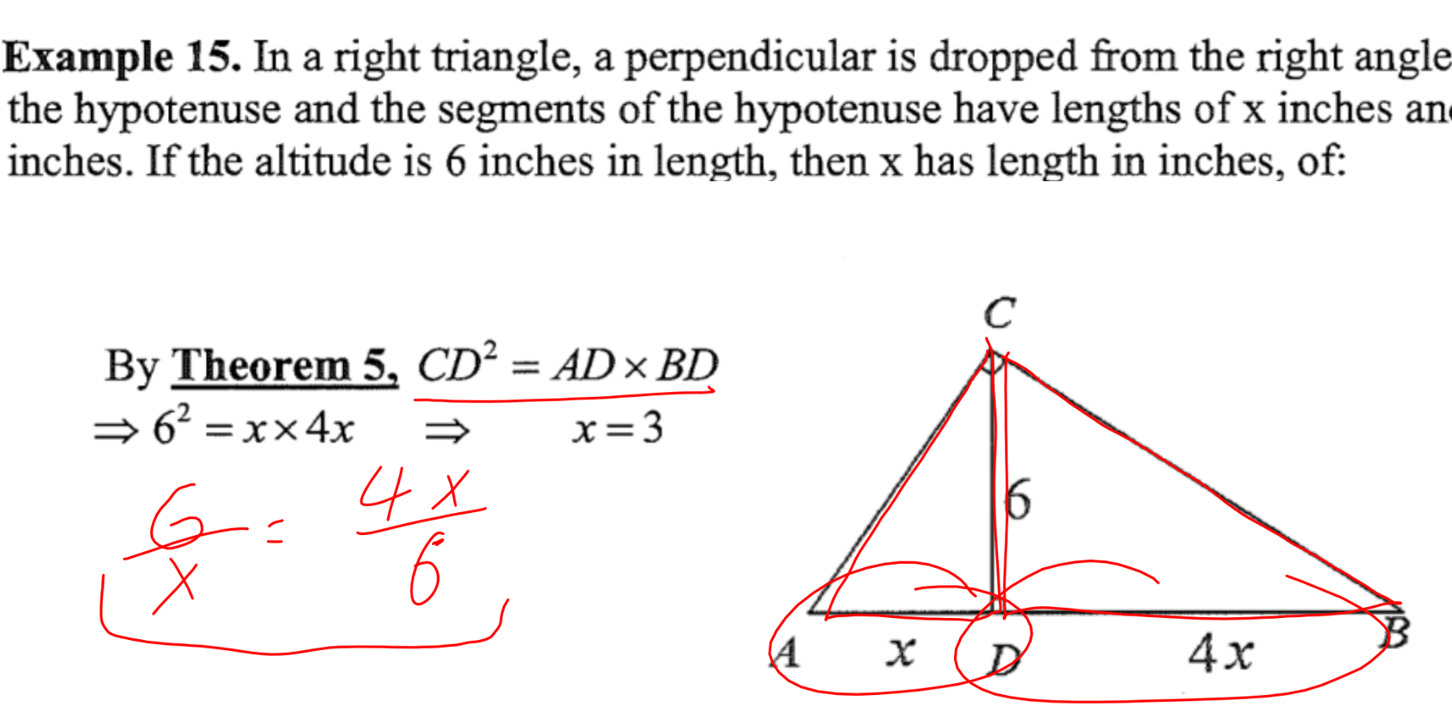

More ideas (Theorem 6 below is frequently assessed by tests and competitions)

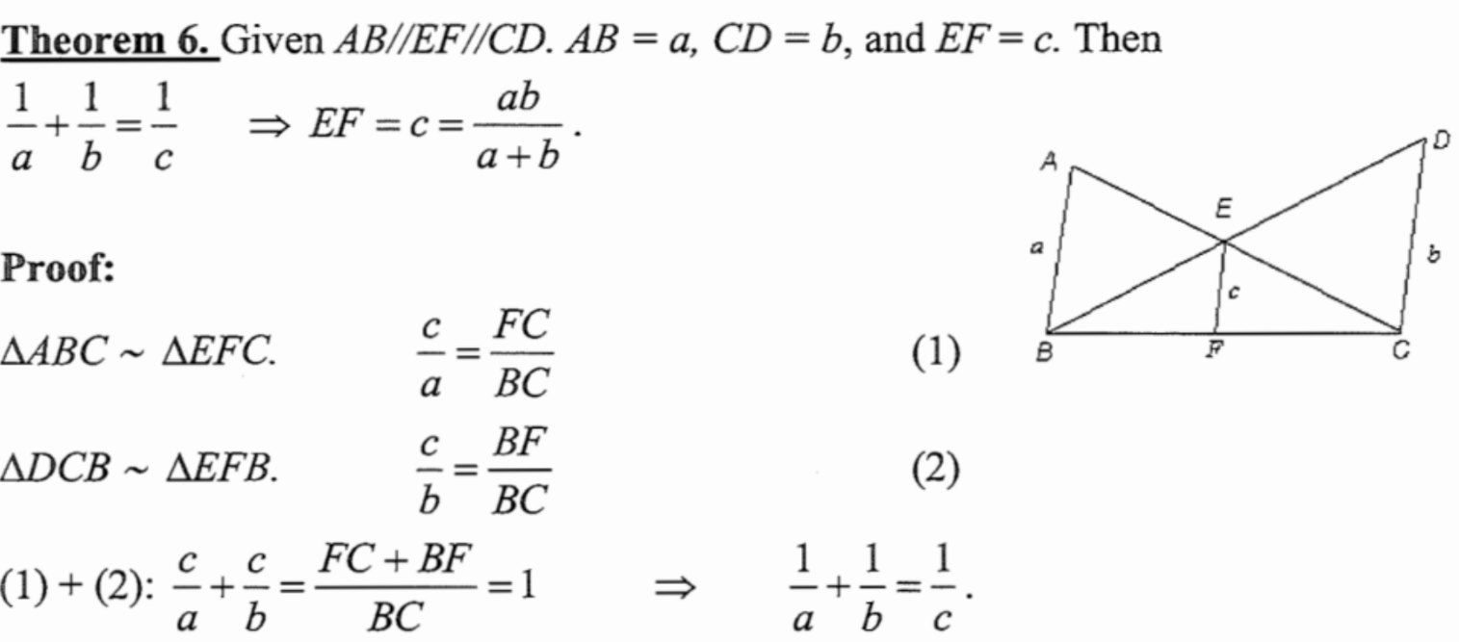

Easier example (referring back)

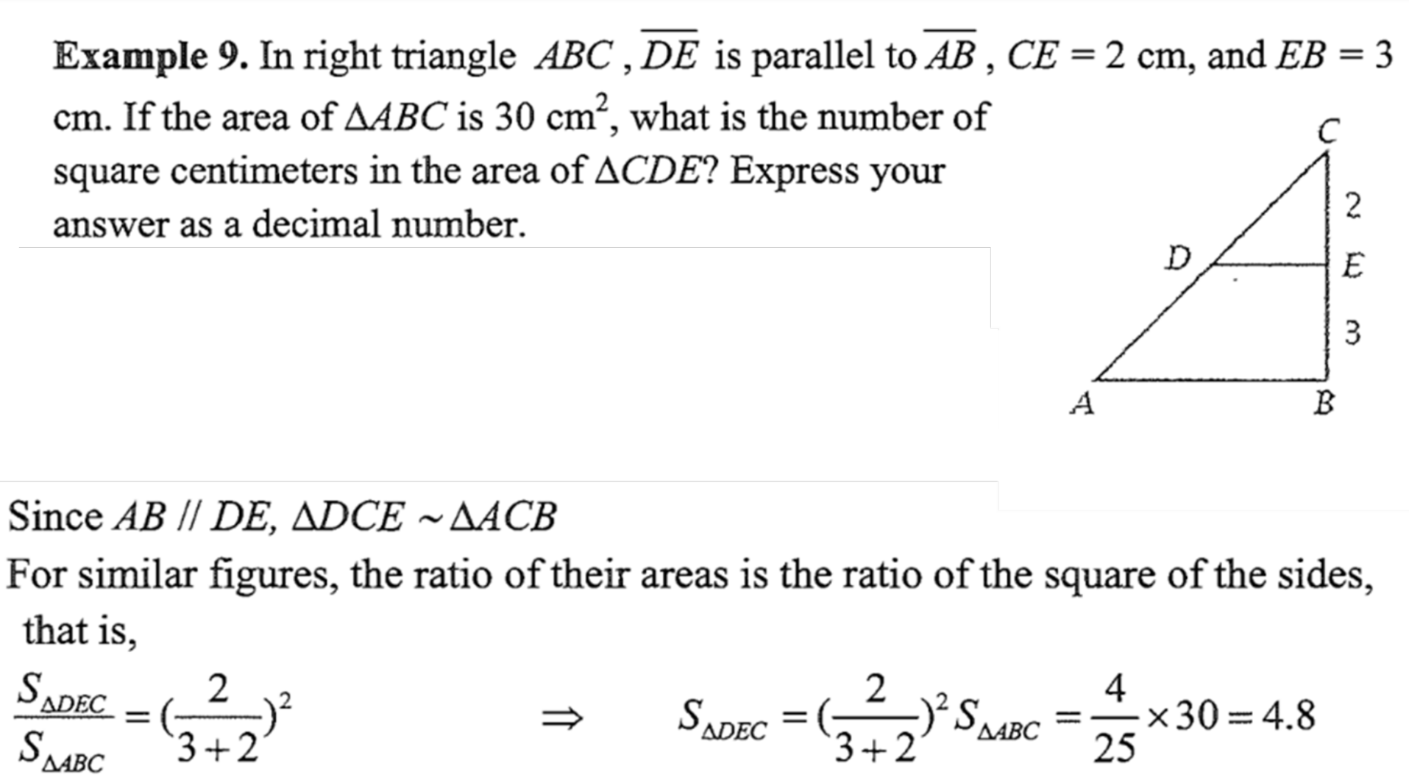

Property (easy to understand too)

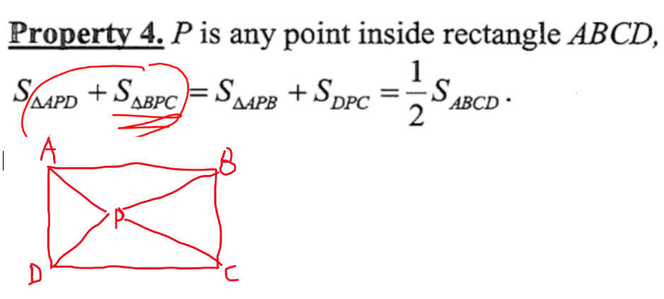



Practise questions (quite hard and some include factorising):

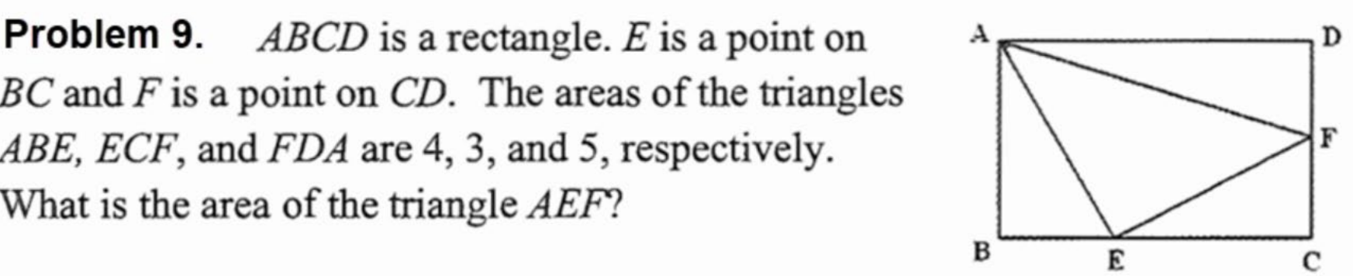



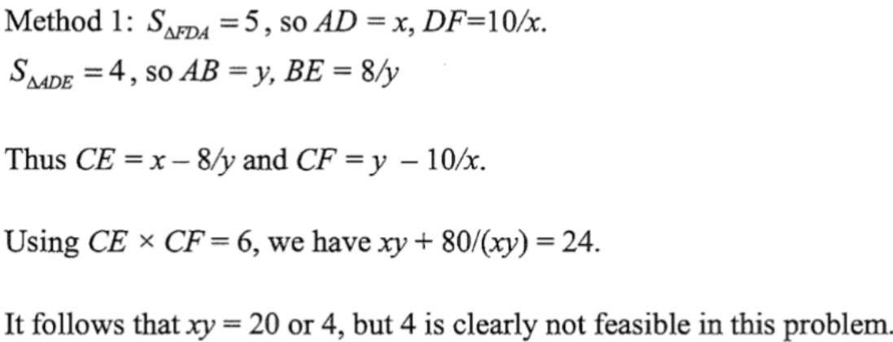

*Because $\left(x-\frac{8}{y}\right)\left(y-\frac{10}{x}\right)=6$*

Note that this explanation is not fully clear, please try to work things out.

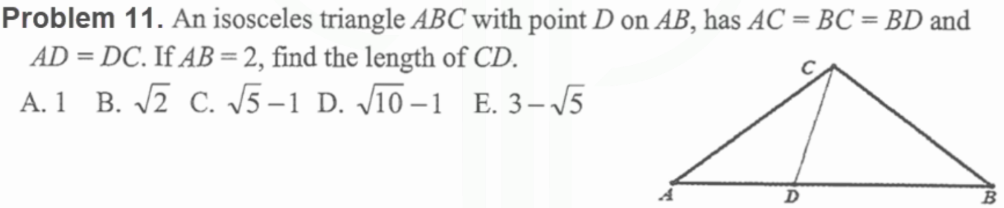

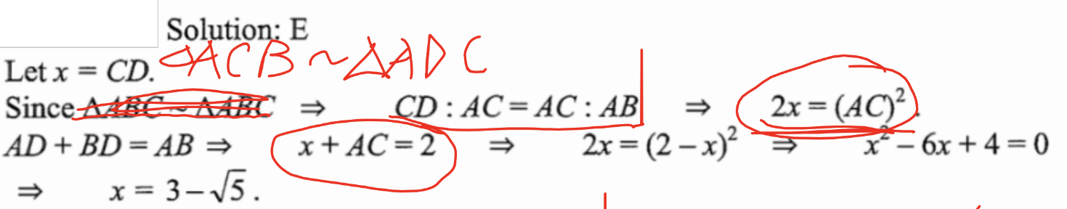

Note that this explanation is not fully clear, please try to work things out.

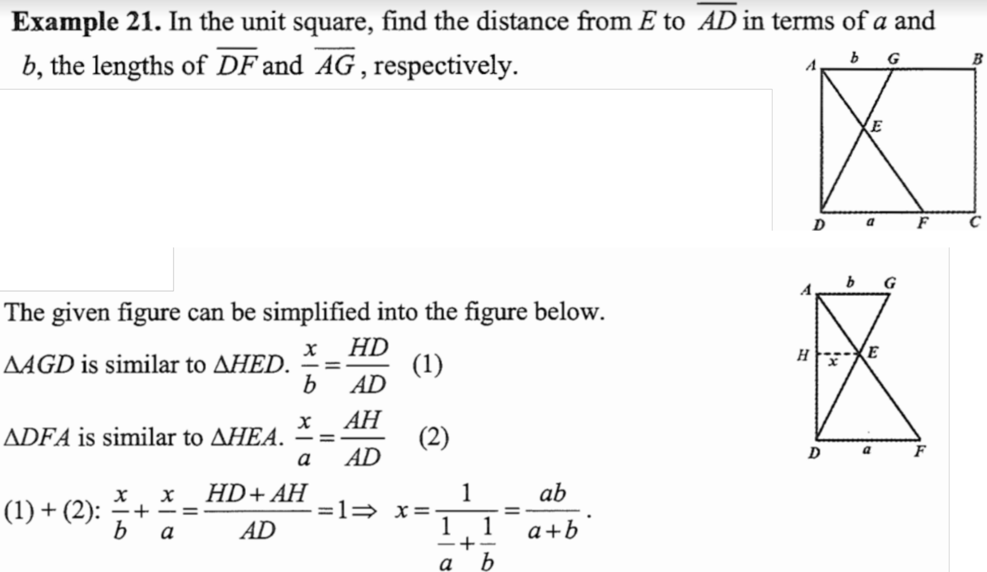

It is handy to remember Theorem 6 from above, but proving it is equally important

The topic of “similar triangle” ceases

***Pythagorean Theorem***

Everyone knows the Pythagorean theorem, but who may use it wisely?

There are countless more proofs made every year, but remembering the proofs are not important.

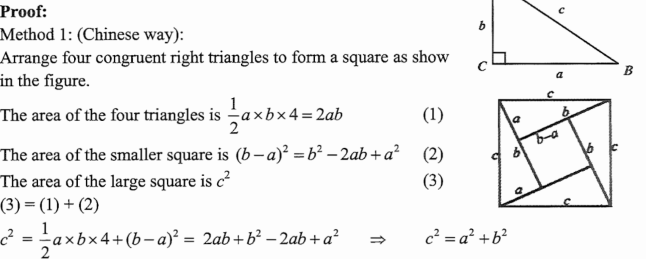



Important theorems, also relating to trigonometry

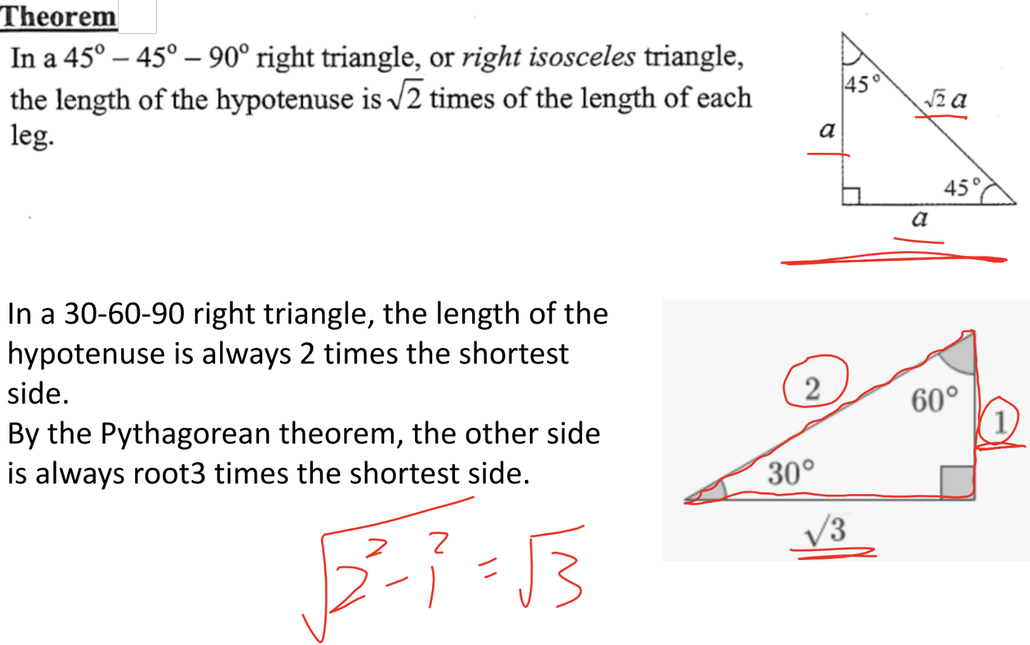

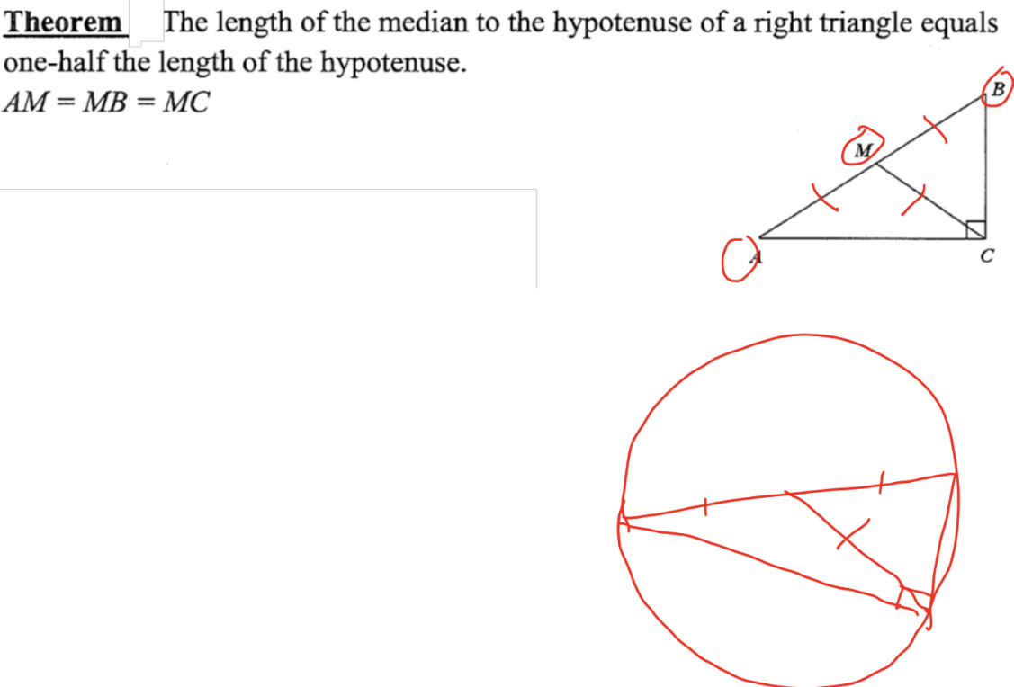

The proof by inscribing in a circle and finding

they are all equal to the radius. This is really

advanced and unimportant now.

Something relating to number theorem:

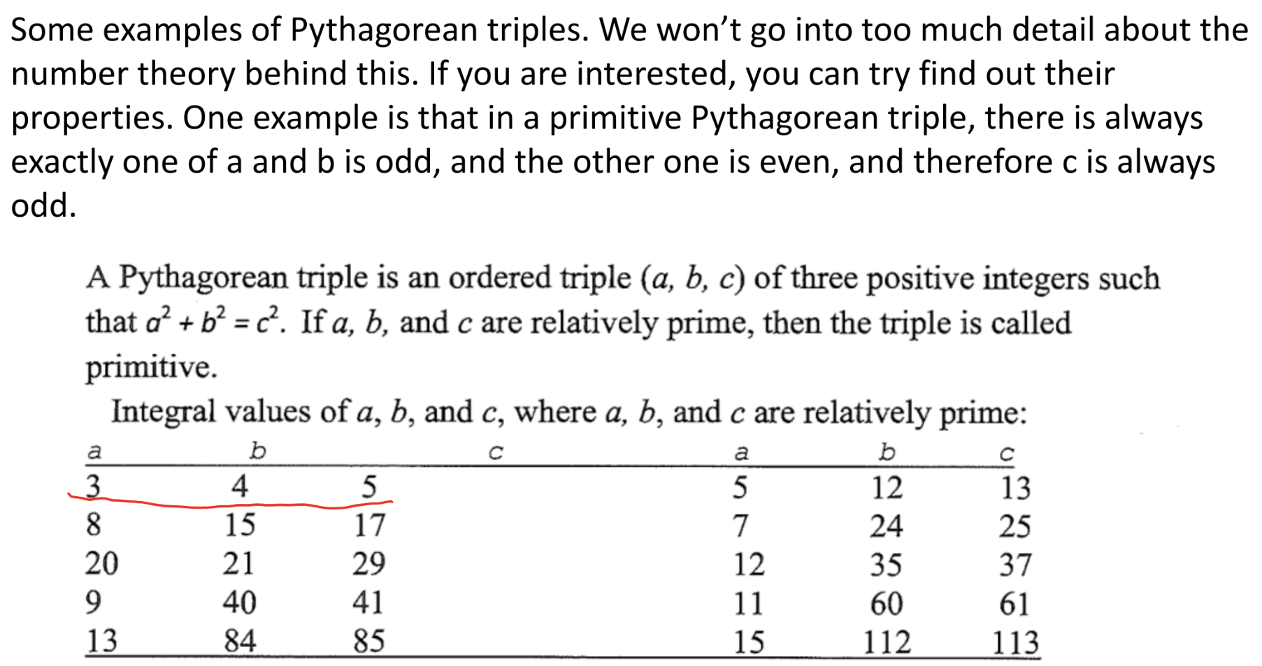

3,4,5 is a primitive triple. You could double the sides of the triangle and create 6,8,10, which is not a primitive triple.

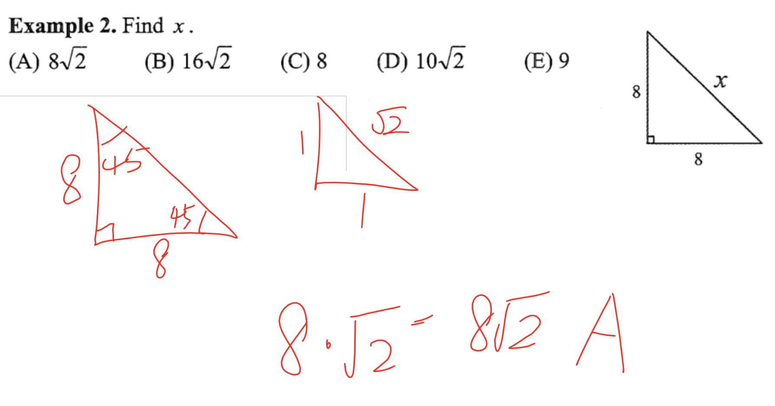

Please note that this is a 45-45-90 triangle

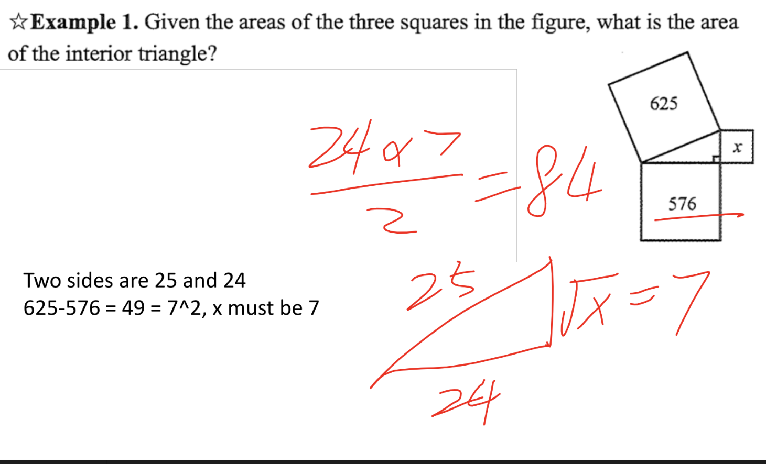

Interesting question:

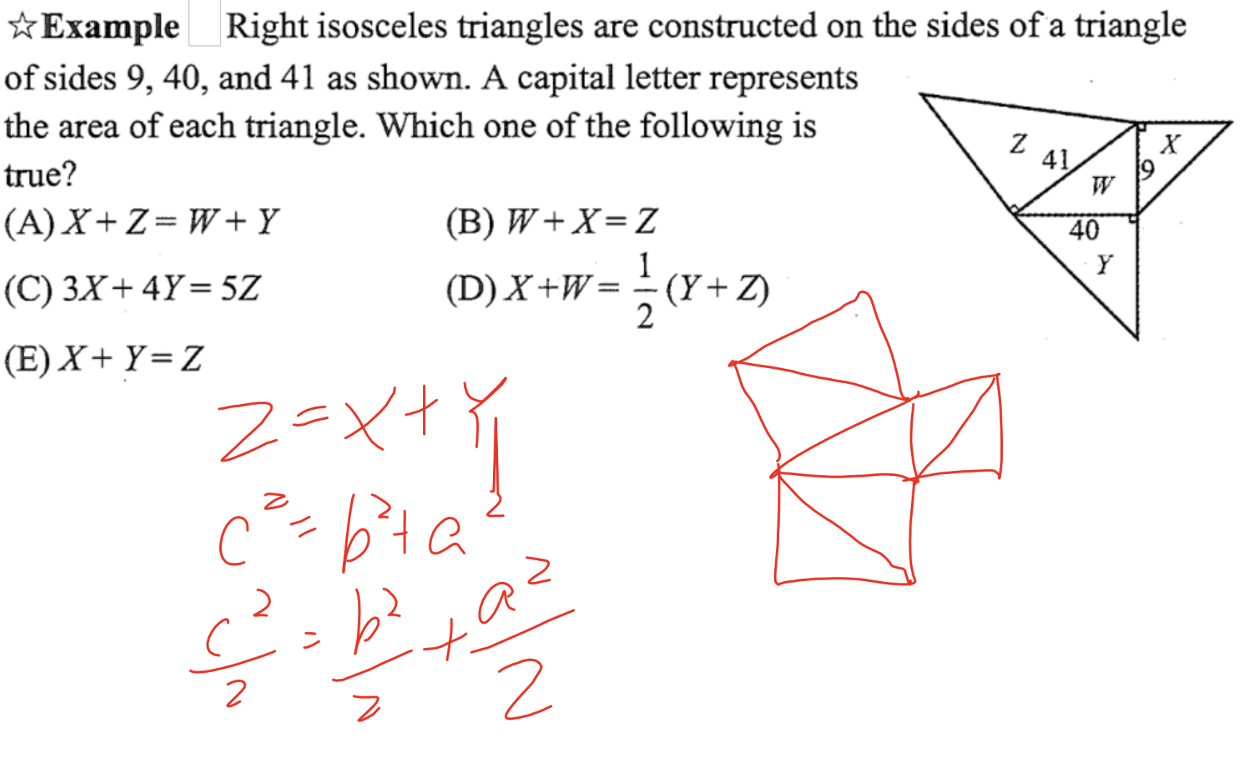

This actually is the same structure as the last question. The squares are just halved to create right angle triangles.

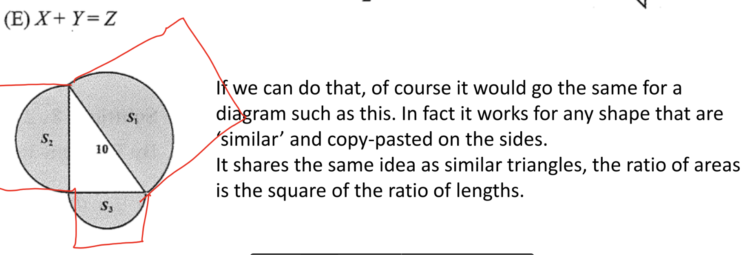



Just some more practise

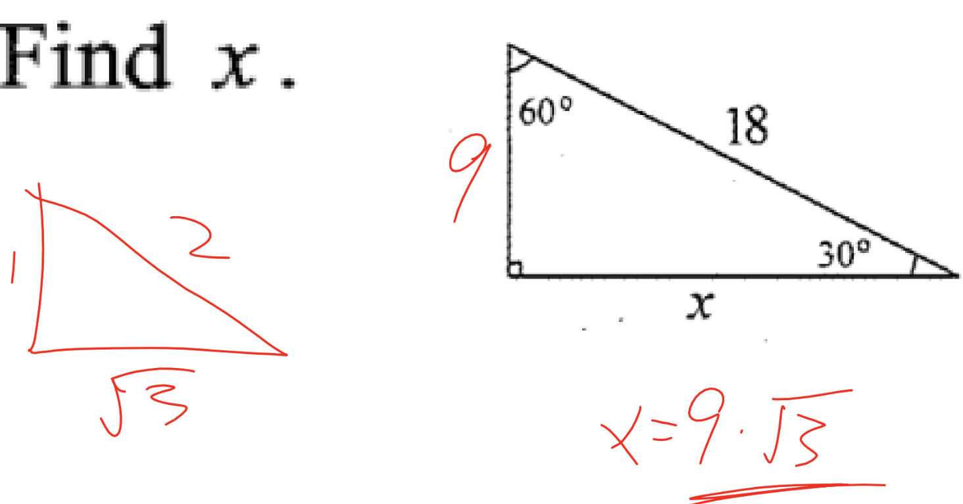

Note that this is a 30-60-90 triangle

Really cool question

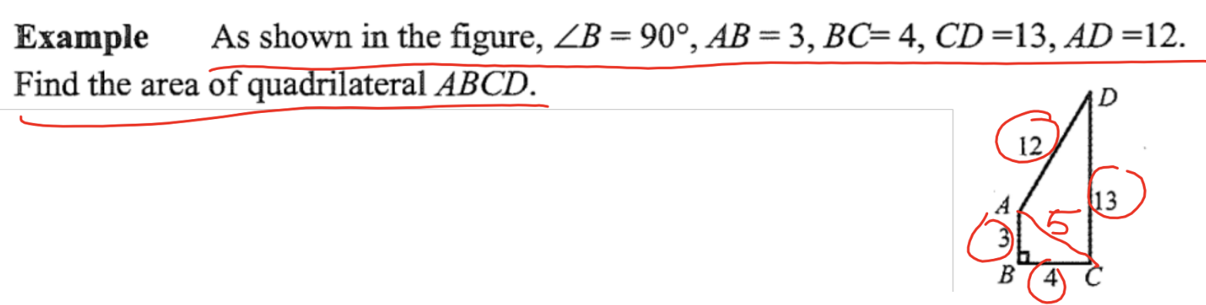

This is a misleading diagram, as AB is not parallel to CD, so the trapezoid equation can’t be used.

We check that 3,4,5 and 5,12,13 are Pythagorean triples, and after calculation we get 36

Yet some more practise…………

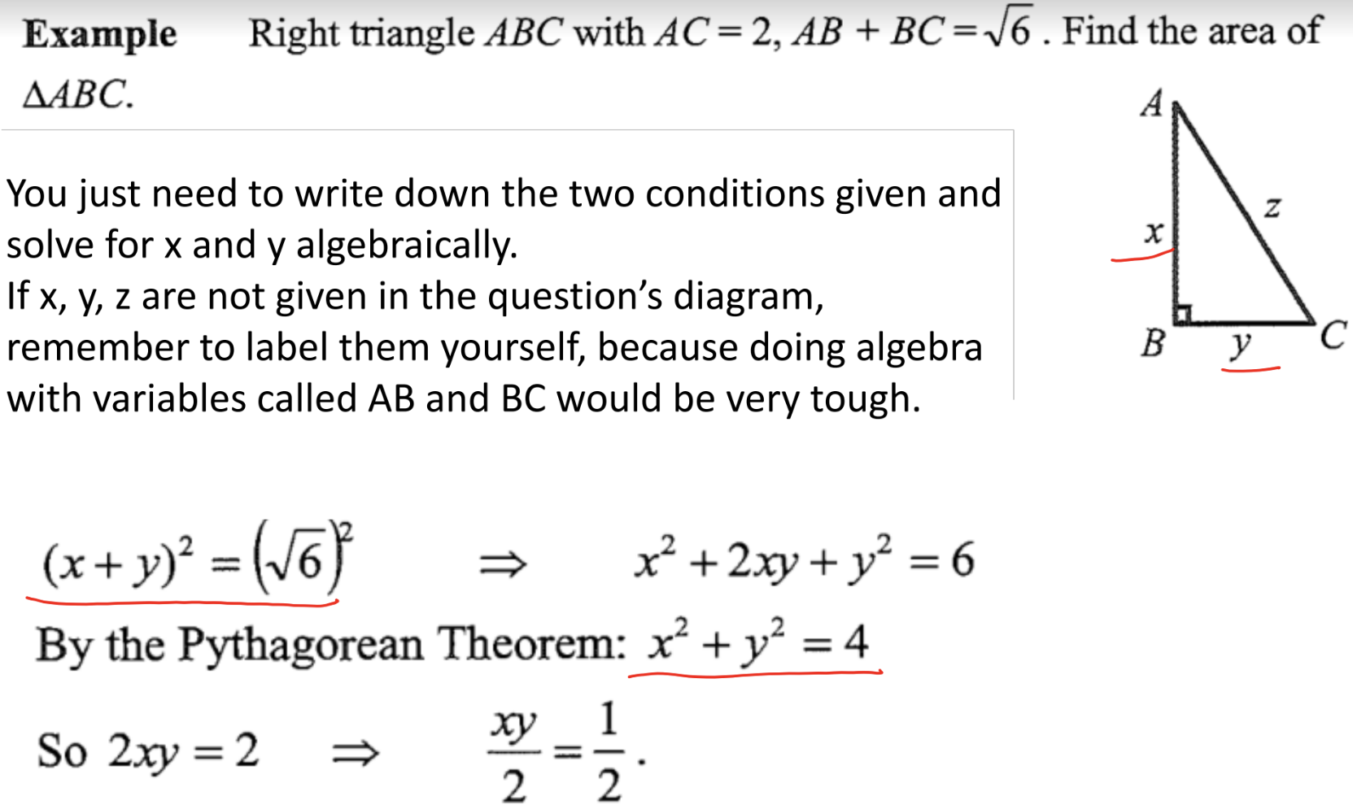

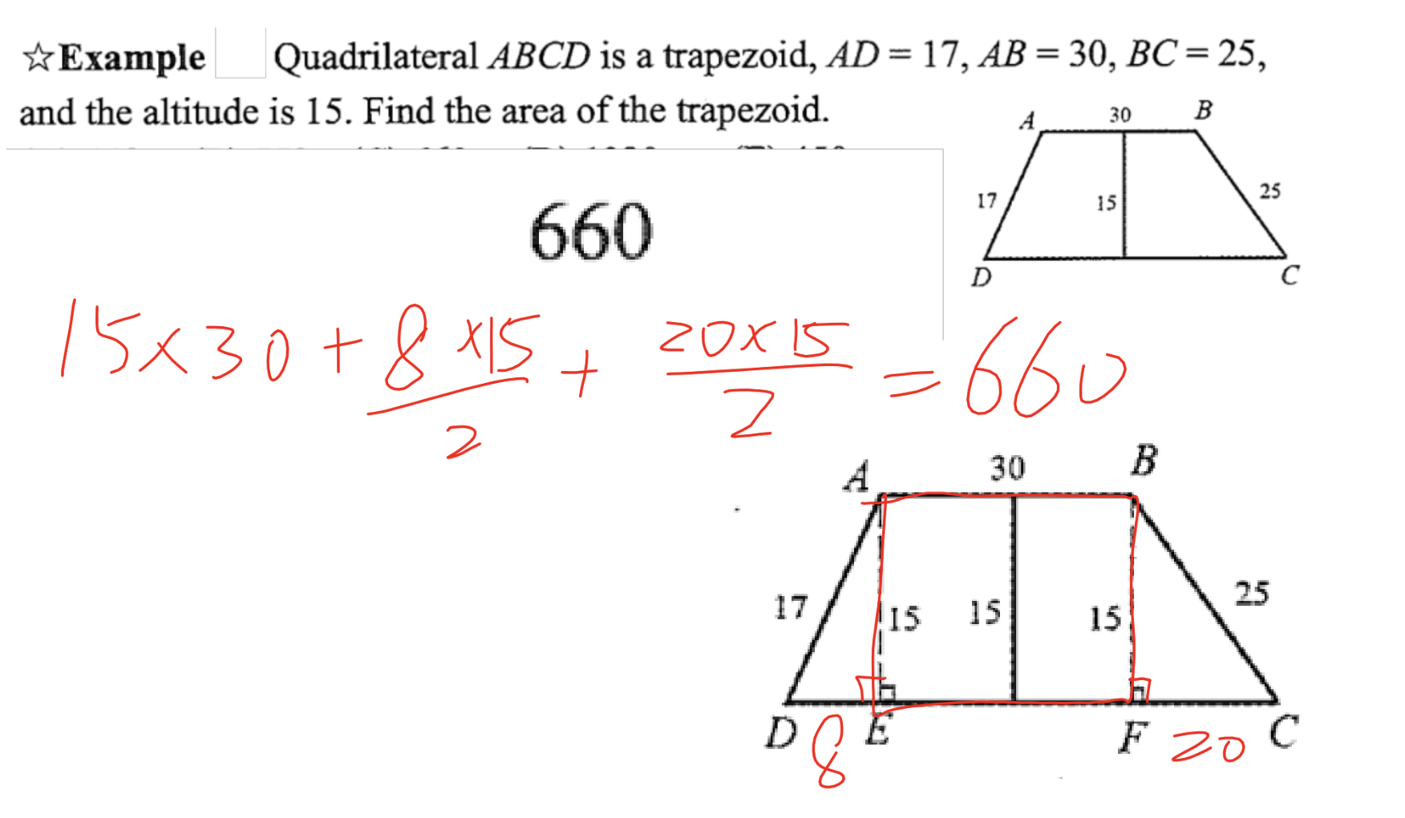

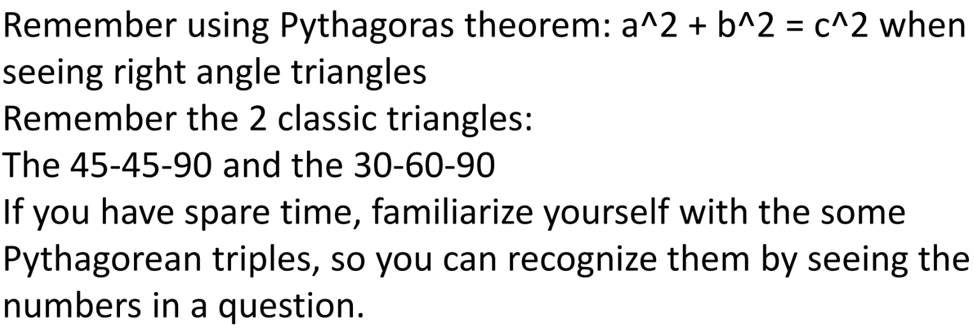

(Remembering some simple Pythagorean triples is useful)

The topic of “Pythagorean Theorem” ceases